North Wall
Length: 5 meters
Bird’s Eye View

220cm
75cm
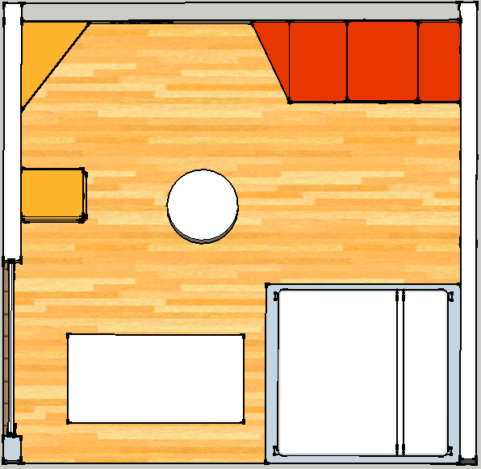
70cm
Door
90cm 5cm
60cm
45cm
200cm 5cm
80cm
55cm
80cm
East Wall
Length: 5 meters
220cm
200cm
45cm
Pillar
Window
Jewelry Box
100cm 5cm
Drawer 3
Drawer 2
Bed Base
180cm
Mattress
Drawer 1
Yoga
Mat
45cm
120cm 5cm
**Please note that the mattress is square shaped. ***

Ground Level View
(From South)
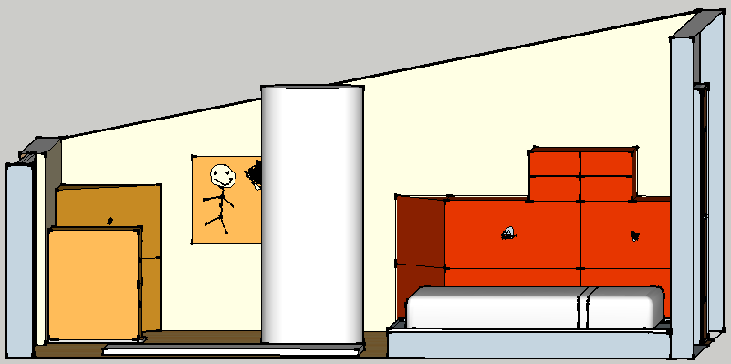
110cm
Window
75cm

Pillar
120cm
200cm
140cm
Door
Jewelry Box
40cm
25cm
20cm
Bed Base
Mattress
25cm
Drawer 2
West Wall
Height: 180cm
Drawer 3
Drawer 1
East Wall
Height: 250cm

Angled View
(From South)
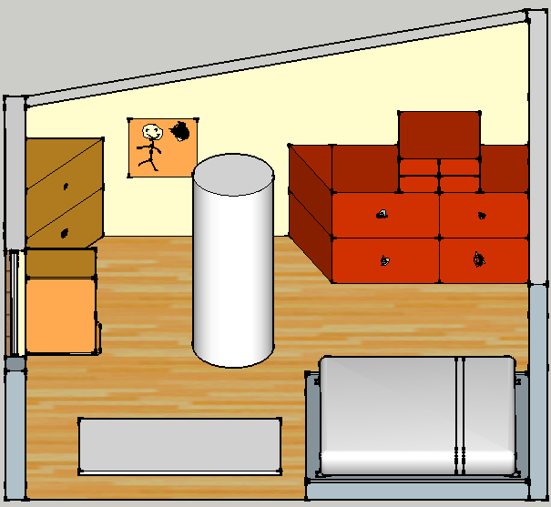
**Please note that the mattress and the painting on the wall are square shaped.**

East Wall
Height: 250cm
120cm
200cm
Yoga
Mat
Bed Base
Pillar
80cm
140cm
25cm
40cm
75cm
110cm
Drawer 2
70cm
Drawer 1
Window
Drawer 3
Mattress
Jewelry Box
45cm
West Wall
Height: 180cm

